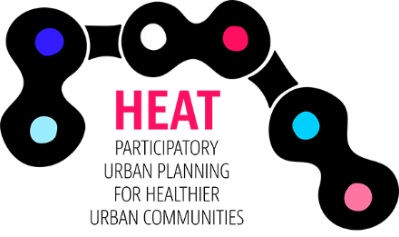
DEFINING YOUR CAMPAIGN
Now that you’ve decided on a campaign idea you need to clearly define which problem it is to address and what your proposed solution is. A clear campaign ”logic” is a key factor to success. A clear and concise formulation of the problem and solution is useful in making sure that everybody involved in your campaign can easily communicate the issue and campaign message to other stakeholders and citizens.

Remember to stick within the scope of the HEAT project: participatory urban planning for healthier urban communities and promotion of bicycling.

Write a few sentences answering each of the following:

- Identify the problem (i.e. streets are unsafe for children / workplace health and morale declines in the winter)

- Formulate a solution (i.e. urban planning needs to take into account children’s perspectives / employees can bike to work which would improve health and morale)

- Describe how to implement the solution and who will do so (methods/activities) (i.e. The municipal urban planning department will develop and market an app where school kids can provide input to the planners / A “bike to work” winter challenge for employees, participants get free winter tires /lights )

Elevator Pitch:
Put together the three ideas above into one or two sentences that can quickly and succinctly communicate the issue and your proposed solution.

Adapted from the Alliance for Biking & Walking Campaign Planning Workbook

It is important to identify and clearly define the problem for your campaign to target so it will have the most impact. Campaigns that don’t target the real issues and relevant stakeholders are ineffective in creating lasting change, no matter how exciting and flashy they seem! If you have trouble defining the ”correct” problem try doing a problem tree analysis. See for example: https://www.odi.org/publications/5258-planning-tools-problem-tree-analysis http://www.comminit.com/dfid/content/problem-tree
It is important that the proposed solution is in direct relation to the identified problem. It should in a way be a mirror of the problem. Be wary of having a solution/activity that you want to do first and identifying a problem to match it. Follow the campaign logic – it will make for a better campaign!

